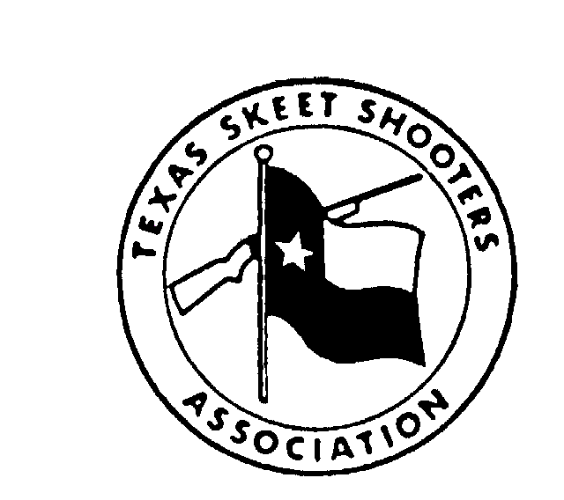
TEXAS SKEET SHOOTERS HALL OF FAME

Individual Information Sheet

THE TEXAS SKEET SHOOTERS HALL OF FAME is limited to four inductees each year. Three of these inductees will be considered on the basis of shooting proficiency. The other inductee will receive the Buck Stark Service Award for outstanding dedication to the sport. Any inductee must have been a resident of the State of Texas for at least ten years and have a record of at least ten (10) years of registered skeet shooting in the State of Texas.

Only persons who have exhibited a high degree of sportsmanship may be considered regardless of other qualifications.

The nominee is being considered for:

Shooting Proficiency

Buck Stark Service Award

Name ________________________________________ TSSA No. __________ NSSA No. __________

Address _____________________________________________________________________________

Occupation __________________________ Date of Birth ____________Date Deceased ____________

Number of years shooting registered targets in the State of Texas _______________________________

Number of years as a resident of the State of Texas __________________________________________

Please complete the attached form giving the following information about the applicant:

- NSSA and TSSA Titles won: to include the name of the shoot, location, title won, score, and year.
- Major accomplishments, such as All State Teams, All-American Teams.
- TSSA and NSSA offices held.
- Gun Club Membership or other skeet shooting groups.
- Contributions to TSSA (what has the person done?)
- Other accomplishments
Nominated by _____________________ Interviewed by ______________________ Date ____________

Word Docs\TSSA\HOF\Application Form
09/01/97
Attachment 1 (use other sheets as necessary)
TSSA Hall of Fame resume for _________________________________________Date______________
1. NSSA and TSSA TITLES WON
Name of Shoot Location Title Won Score Year
______________________________________________________________________________________________________________________________________________________________________________________________________________________________________________________________________________________________________________________________________________________________________________________________________________________________________________________________________________________________________________________________________________________________________________________________________________________________________________________________________________________________
2. MAJOR ACCOMPLISHMENTS: ALL STATE and ALL-AMERICAN TEAMS (include years)
_______________________________________________________________________________________________________________________________________________________________________________________________________________________________________________________________________________________________________________________________________________
3. NSSA and TSSA OFFICES HELD (include years).
______________________________________________________________________________________________________________________________________
- GUN CLUB MEMBERSHIP OR OTHER SKEET SHOOTING GROUPS (include years).
______________________________________________________________________________________________________________________________________
- CONTRIBUTIONS TO TSSA (what has the person done?).
______________________________________________________________________________________________________________________________________
- OTHER ACCOMPLISHMENTS
______________________________________________________________________________________________________________________________________
- COMMENTS
______________________________________________________________________________________________________________________________________
PLEASE SEND THE COMPLETED FORM TO: TSSA, 201 LAURENCE DRIVE, SUITE 106, HEATH, TX 75032 FOR FORWARDING TO THE CHAIRMAN OF THE HALL OF FAME COMMITTEE

